Explore Assistant Tuning
Micron Installation

Explore Assistant Architecture
Explore Assistant is an ‘Extension Framework’ Javascript application. It runs within looker, and is available through the Applications menu. It calls LLMs through GCP Vertex, using OAuth to authenticate users. Setting up this configuration is outside the scope of this document.

Explore assistant uses 3 tables stored in Bigquery:

- Samples
  - Sample starting questions, presented as clickable conversation starters.
- Examples
  - Detailed example questions and encoded explore url responses.
  - This is the table we tune to improve responses.
- Refinements
  - Used to determine if a question is requesting a data summary or not.

Examples Table
The proper name of the table is explore_assistant_examples. This table has one row per Explore, and 2 columns: examples and explore_id (PK). The examples column contains a string encoded json object with this format:

[{“input”: “User question or prompt”, “output”: “url encoded looker query string”},{input… }]

Here is an example of one of the input output pairs:

{"input": "Show me total sales by brand in January 2024",
"output": "fields=order_items.total_sales,products.brand&f[order_items.created_date]=2024-01&sorts=order_items.total_sales+desc+0"}

These pairs will be fed to the LLM as examples of what it’s output should look like. They are very important. If an invalid output is provided, the LLM will mimic it and produce an invalid result. To make these as useful as possible, they should be considered ‘Golden Queries’ and treated with care.

How to Create Golden Queries
The output for golden queries can be found in the ‘Share’ menu in a Looker Explore.
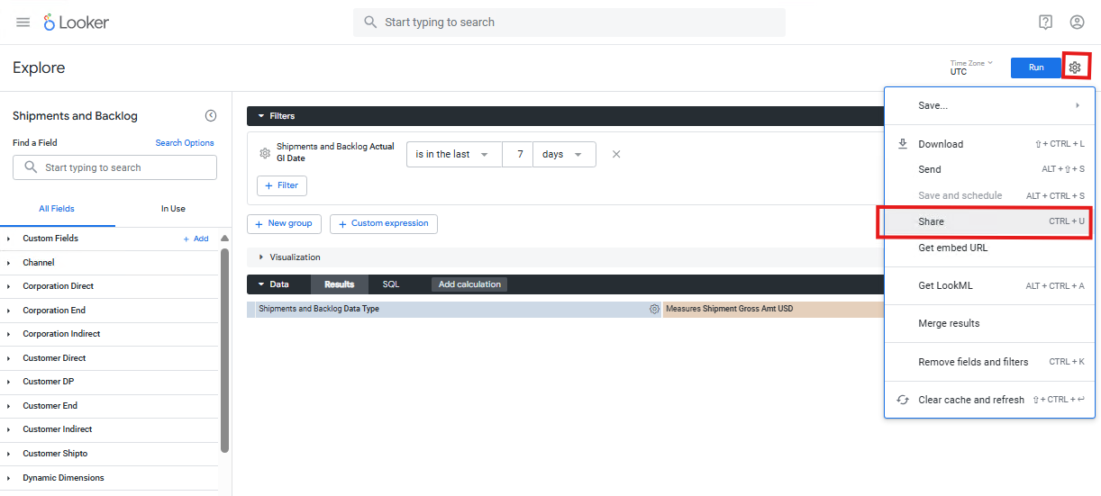
Copy the ‘Expanded URL’
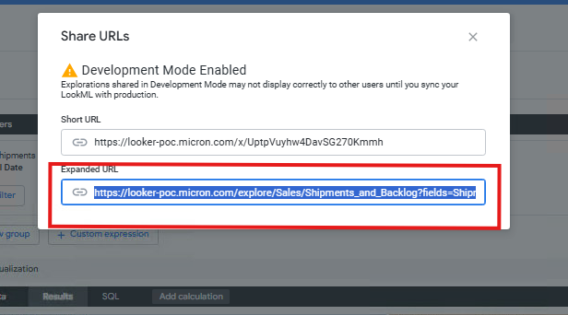
Trim the expanded URL value to only include characters after the question mark(?). These are your URL-encoded Query Parameters.

Using explores that answer important questions and show diverse, but correct patterns is important. Visualization data is also part of the Query Parameters. Data is preserved as you continue to work on examples, so this needs to be ‘cleared out’ between each example.
Warning: When creating examples, please start with a fresh explore (from the Looker Menu) each time you create one. Otherwise, invalid visualization parameters may carry over to the next example.

What Golden Queries to Create?
It is difficult to provide an exact answer for which queries to provide the LLM. Providing too many can be detrimental. This kind of prompt engineering is as much art as science. Here are some examples of queries you may want to create. ~5-30 examples should be sufficient.

- Query top level standard metrics (ie. Gross Amt USD) with commonly used date filters (current month)
  - Example Question: “What are the gross total dollars in shipments this month?”
- Query top level standard metrics across dimensions, filtered to certain dimension values.
  - Example Question: “What is the Net Amount across each channel, for the channels ‘direct’ and ‘b2b’”
- If there is common but complex date filtering used in reporting, provide an example of each one.
  - Example Question: “What is my YOY change in Gross ASP?”
  - Would lead to a filter like ‘last 8 complete quarters’, pivoted appropriately
- Include at least one line chart at the desired level of granularity
- Include at least one pivoted chart
- Include queries using specific, non-intuitive nomenclature

Beyond the above questions, you may need to add additional golden queries when the Explore Assistant fails to get a result correct.

